CS 251 Statistical Computing

**R installation for MacOS**

2/19/2020 Developed by Aya

3/30/2020 Reviewed by Apiwat Chuaphan

10/16/2020 Reviewed by Shanshan Yu

Center for Information Assurance (CIAE) @City University of Seattle (CityU)

**Before You Start**

* If you already finished this module through any CityU Technology Institute (TI) courses,  
  just skim this module and skip it.
* Version numbers may not match with the guide. But that should be fine.  
  If given the option to choose between stable release (long-term support) or most recent, please choose the stable release.
* This guide targets Windows OS users. So, MacOS users may have different commands to input in the shell/terminal.
* We cannot explain every step. **This cookbook always needs your own creative judgement.**
* **For your working directory, use your course number.** The hands-on tutorial may use a different course number as an example.

**Learning Outcomes**

* Installing R for statistical project
* **Installing R for statistical project for Windows OS**

1. Visit <https://www.r-project.org/>
2. Choose **download R**

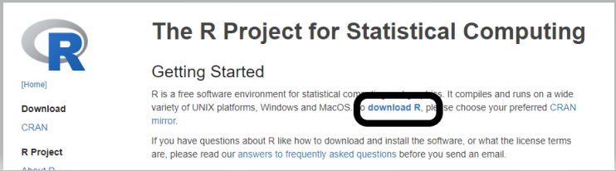

1. Scroll down to **USA** and click on the second link**.**

**If the second link isn’t working, try the third link.**

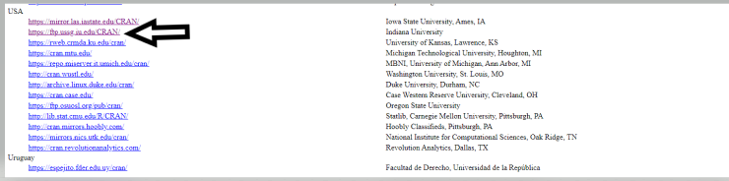

1. Select **Download R for Mac**

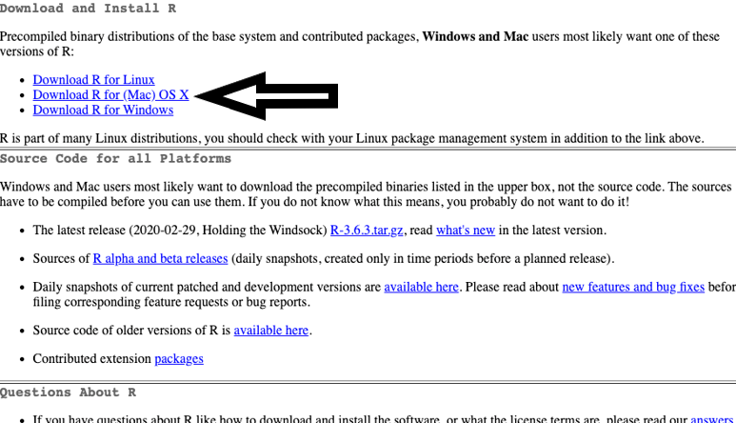

1. **Choose the latest release**

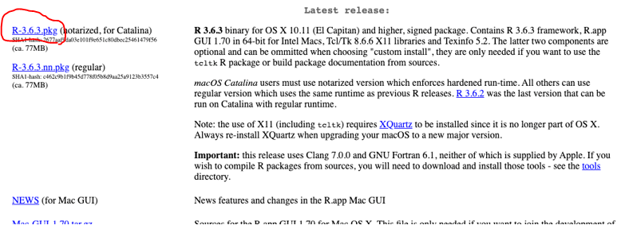

1. **Install the R on your machine**

**Press continue, and agree**

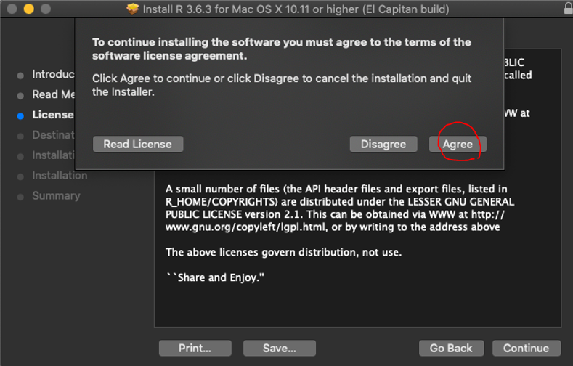

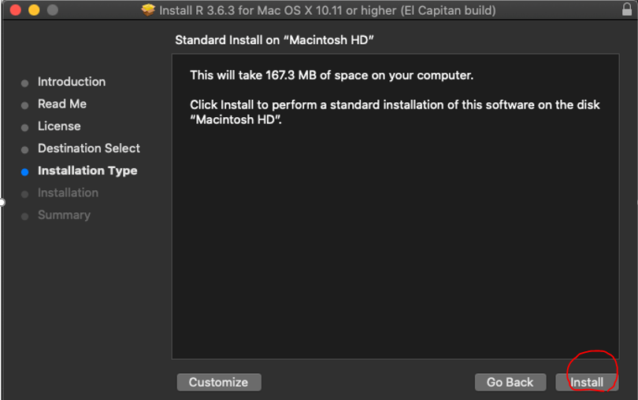

**Make sure that you see the installation was successful**

1. Open VScode and select extension, search for R, then install

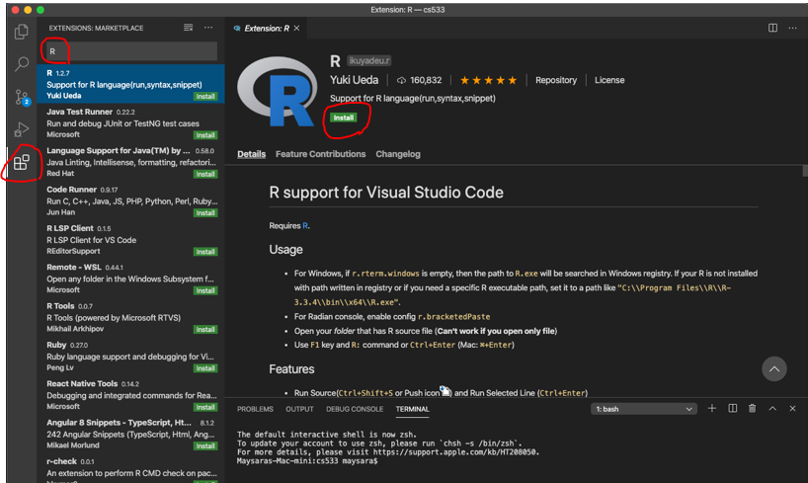

1. Close the Vscode and open it again

**Setup Working Environment for Module**

1. Open VS Code.
2. Go to your project folder

* Open Desktop\CS251\hop01-YourUserName (File > Open folder)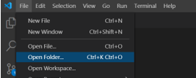

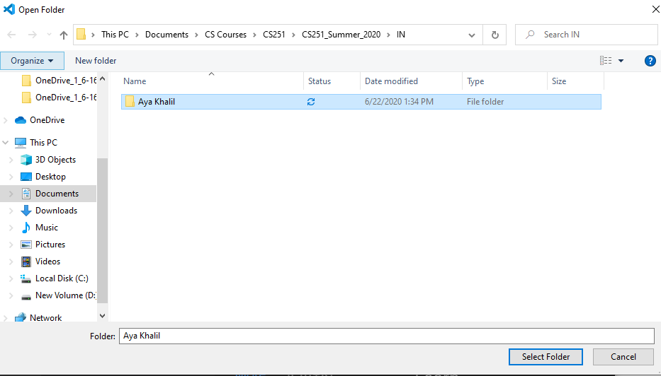

1. Then, in “**Module1**” directory in the VSCode.

* Right-Click on Module1 and select new file

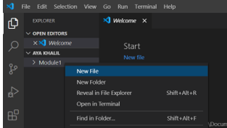

* Create new file hello.R in Module1 project folder
* Write the following in hello.R file

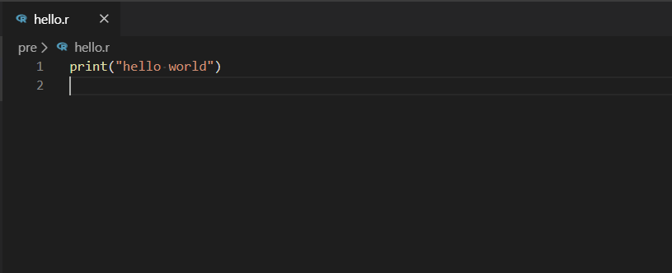

5)Don’t forget to save your file File>save or ctrl+s

6)To run your code press Run Source

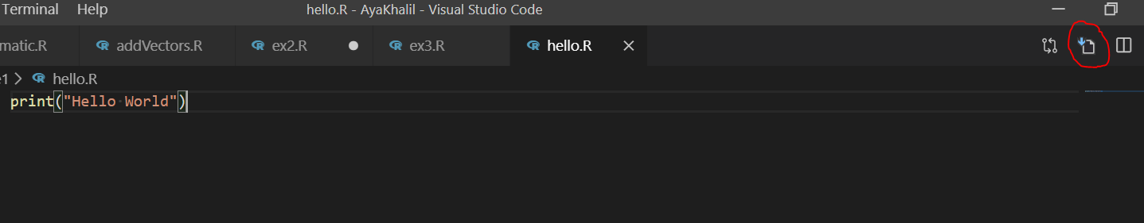

7) Your output should be:

